**The model is developed using COMSOL. Due to the large size of the model and insufficient storage space, we can only briefly describe the parameters of the model here.** **Table 1 shows the geometric parameters of the model.**

Table 1 Geometric parameters

|  |  |
| --- | --- |
| Probe size | Diameter: 2cm |
| Thickness: 0.5cm |
| Tubular fallen object dimensions | Thickness: 2cm; Length: 5cm |
| Inner diameter: 4cm; |
| Length: 5cm |
| Probe excitation frequency | (0.1–2.5)MHz |
| Oil well size | Length: 100cm; |
| Diameter: 20cm |
| Initial distance between the probe and the fallen object | 50cm |

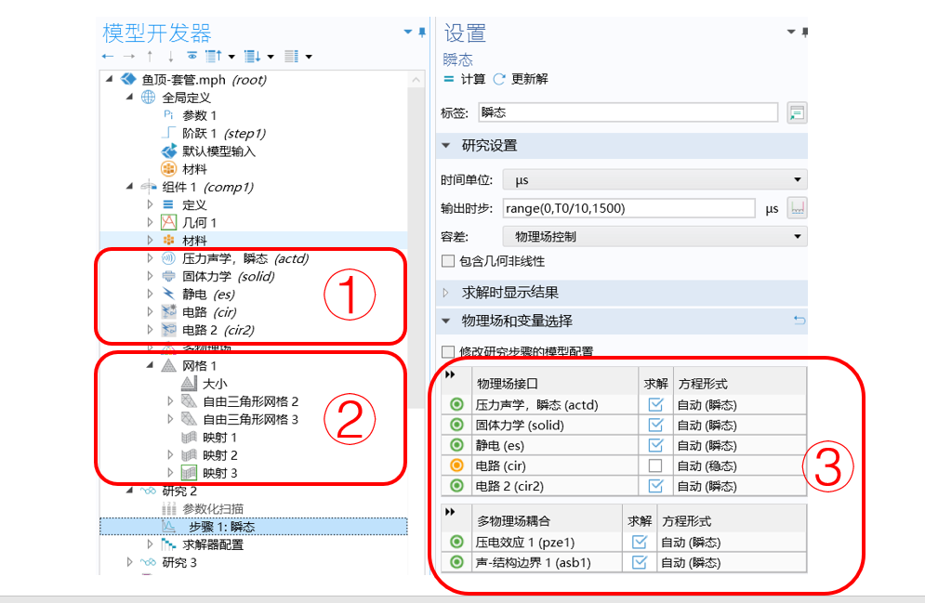

Figure 1 Model Interface

**Figure 1 mainly shows: ① the coupling port; ② Model mesh division; ③ To calculate the coupling between ports and physical fields involved.**

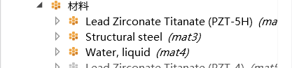

Figure 2. Material List

**Figure 2 shows the materials used in the model： where PZT-5H is the probe material; and structural steel for underground fallen objects; Its environment is water.**

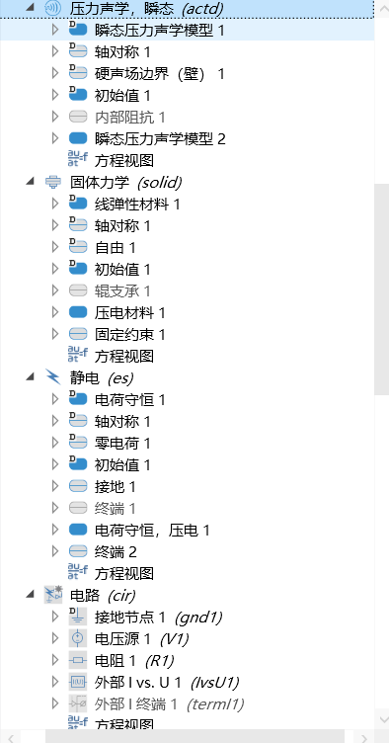

Figure 3. Coupling Port Settings

**Expand part ① in Figure 1 to obtain Figure 3.**

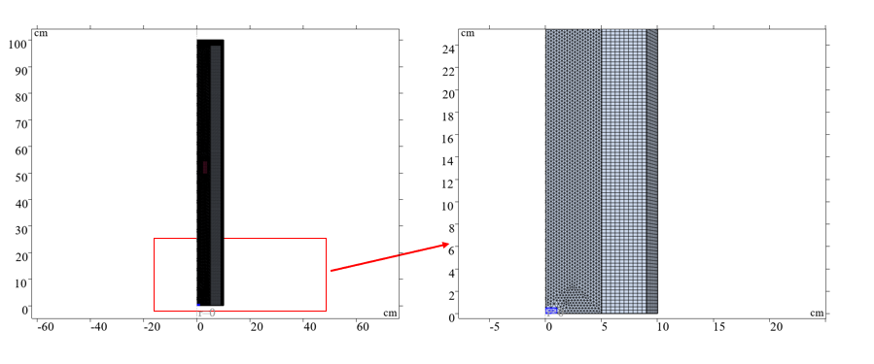

Figure 4. Grid Division

**Figure 4 shows the mesh partitioning effect.**

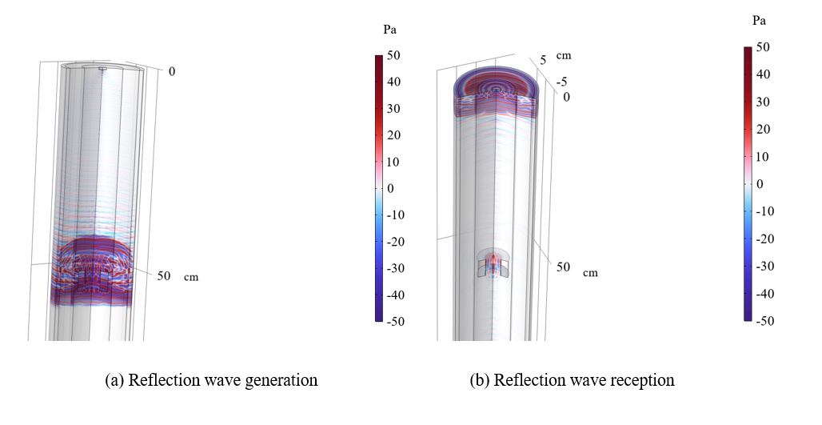

Figure 5. Ultrasonic detection effect of fallen objects

**Figure 5 shows a snapshot of the ultrasonic detection of a fallen object, and the dynamic image will be presented in a separate attachment.**

**The actual model cannot be uploaded due to significant reasons!**